ASSIGNMENT TITLE:
CA LAB
SUBMITTED BY:
ABEERA ASHFAQ
SUBMITTED TO:
PROFF MEHMOOD

SUMMARY OF LAB NO 6
Verification of Kirchhoff’s Laws
This lab focused on the practical verification of Kirchhoff’s Current Law (KCL) and Kirchhoff’s Voltage Law (KVL).
- Verification of KCL (Current Law):
  - Assemble a parallel circuit on a breadboard using resistors (330Ω, 220Ω, and 1kΩ) and a power supply.
  - Set the Regulated Power Supply (RPS) to a specific voltage.
  - Use a multimeter to measure the current entering the node and the currents leaving the node
  - Verify if the sum of entering currents equals the sum of leaving currents for different voltages like 5V, 15V, and 25V.
- Verification of KVL (Voltage Law):
  - Connect resistors in a series configuration according to the circuit diagram.
  - Apply a known voltage from the power supply.
  - Measure the voltage drops across each resistor using a multimeter.
  - Confirm that the total applied voltage equals the sum of individual voltage drops
Safety Precautions: Ensure the voltage control knob is at the minimum position and the current control knob is at the maximum position before starting the power supply.

PROTEUS SCREENSHOTS
TASK1
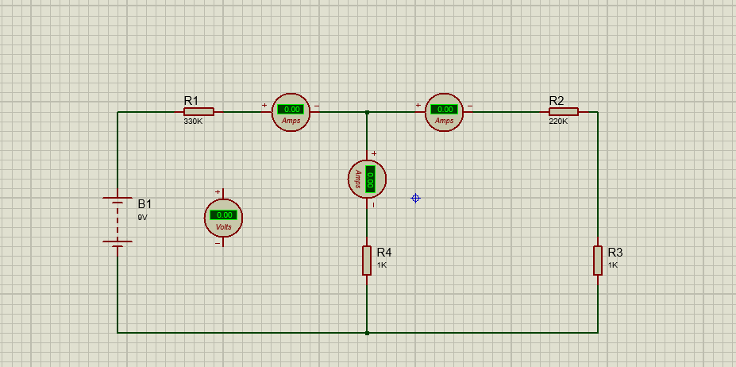

TASK 2


